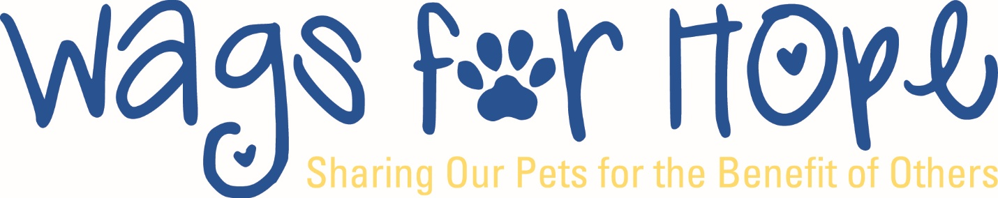
Your Next Steps 
- Read and Sign the pet Team Agreement and have the Pet Health Form signed by your vet. These forms MUST be handed in to be eligible to take the Evaluation.

- Attend the Education Seminar at the C. Burr Artz Library in downtown Frederick in the Community Room on, ______________________________, from 5:30 – 7:30.

- Pass the Evaluation on, ___________________________, at Shookstown Civic Center, Frederick, MD. Contact Sylvia Anderson at sylvia@wagsforhope.org if you have Education or Evaluation questions. Your evaluation time will be given at the Education Seminar.

- Select your top 2 facilities to visit. You will sign up for a facility at the evaluation. (See facilities on our website).

- Your Wags Facility Coordinator will contact you to arrange a shadow visit without your dog. You will be given the name of your facility coordinator at the Evaluation.

- If you are interested in R.E.A.D., after a successful evaluation, contact read@wagsforhope.org
to get started on the R.E.A.D. program. We need R.E.A.D. volunteers.

Volunteer Responsibilities and Check List (√ )
** Member fee $40 ( ) $20 each additional pet( ) $20 Each additional Handler ( )
**Signed Pet Team Agreement (make 2 copies) ( )
** Pet Health Form signed by Vet (make 3 copies) ( ) Keep the original for your records.
**Valid Rabies Certificate

** Items needed before you can become a member
Send Rabies certificate and Pet Health Form to: members@wagsforhope.org
Other Helpful Tips
Wags for Hope holds evaluations several times each year. If you currently are Level I certified pair are interested in visiting the Hospital or Hospice Care, contact Sylvia Anderson

If you want to become Level II certified, contact Sylvia Anderson at sylvia@wagsforhope.org, for a reevaluation using the 2025 evaluation. See our website calendar for the yearly evaluation dates.

Don’t lose touch!! We may have a bit of a hurdle in getting this many people through, but do not give up! If you are having difficulty getting started, contact: members@wagsforhope.org

Wags for Hope Contact List

Connie Barnes President Presidents@wagsforhope.org
Joette Leonard Vice President Joette@wagsforhope.org
Sylvia Anderson Education & Evaluation sylvia@wagsforhope.org

Dolly Sullivan FHH Coordinator dolly@wagsforhope.org
Kristi Wood Facility Director/Community Liaison kristi@wagsforhope.org
Kelly Bongard R.E.A.D Program read@wagsforhope.org
Bonnie Johnson Orientation Director bonnie@wagsforhope.org

Michelle Trite Membership administrator members@wagsforhope.org

Wags for Hope PO Box 1279, Frederick, MD 21702

Evaluation Tips:
Pets must wear proper collar: Buckle, Harness or gentle leader on a 4-6 ft leash (NO choke, prong or pinch collars and no flexi leads)

Get to the evaluation about 15 minutes early to acclimate your pet to the environment. If you relax your pet will have a better chance at relaxing too!

