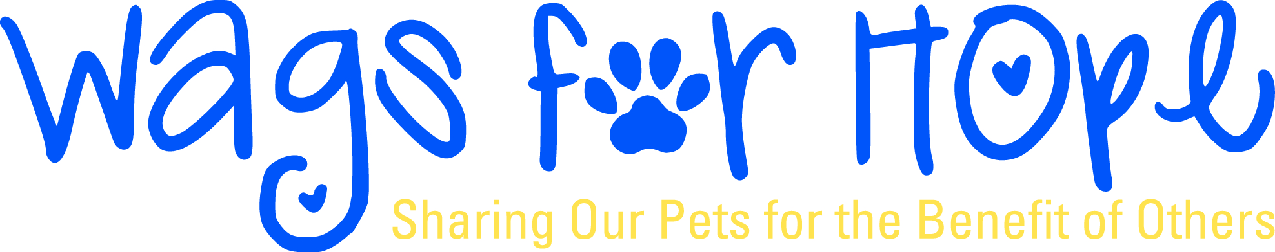

R.E.A.D. Program Information

Dear Wags for Hope Teams,
Have you been interested in becoming a R.E.A.D. (Read Education Assistance Dogs) Program team and just have not gotten around to taking the test? Now is your chance to become a part of the R.E.A.D. program. If you are not familiar with the program, you can find out more information here:
http://www.therapyanimals.org/R.E.A.D.html
Wags for Hope currently has R.E.A.D. programs at many of the libraries in Fredrick County as well as several outside the County. R.E.A.D events also include school events and the summer reading clinic at Hood College. We have organizations that are interested in the R.E.A.D. program, but we need your help!
To become a R.E.A.D. team you must:
1. Be a Wags for Hope Therapy pet team.
2. Watch the R.E.A.D. video. The video is now available on line at
http://www.youtube.com/user/ita4me

3. Buy a R.E.A.D. training manual and complete the written test. This book is available through
Wags for Hope for $35.00. Contact read@wagsforhope.org to get your copy.

4. Attend the Wags for Hope R.E.A.D. training. You may take this class anytime during your
R.E.A.D. process.

5. Shadow a R.E.A.D. team in action without your pet.

6. Shadow with your pet and a veteran R.E.A.D. team.

Don’t hesitate to email read@wagsforhope.org if you have any questions!

