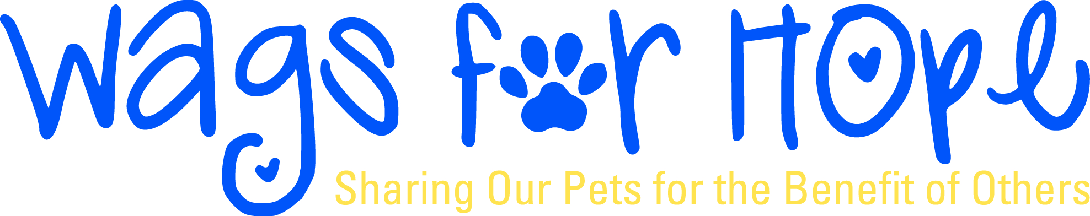
Volunteer Pet Team Agreement
As a Wags for Hope (WFH) member you agree to the following:
Getting ready to visit:
- Complete orientation.
- Pay $40 member fee. ($20 for each additional family member, $15 for each additional pet)
- Complete the WFH (Wags for Hope) education seminar.
4. Pass pet evaluation; submit pet's health form, rabies certification and this agreement at that time.
5. Complete 1st and 2nd shadow visits accompanied by Wags representative.
6. Complete paperwork for assigned facility.
Once you are ready:
- Visit on agreed-upon schedule.
- Notify facility of any one-time only schedule changes.
3. Notify your WFH (Wags for Hope) Facility Coordinator immediately of permanent schedule changes,
changes in your contact info and immediately for any incident.
4. Leash must be in handler’s hand at all times and animal is under control
In order to continue visiting:
- Submit a copy of your updated rabies certificate to WFH every 3 years (or yearly if your booster is yearly). If we do not receive a copy of that updated certificate, you will not be able to visit.
- Provide a negative fecal result from your veterinarian yearly.
- Provide a copy of your pet’s health record to your facility yearly.

Additional requirements:
- Pets must be at least 1 year old. If your pet is adopted, it must have lived in your home for at least 6 months, documentation may be required.
- Handlers 10 - 17 years of age must be accompanied by an adult at all times and a parent child waiver must be signed before visiting.
- Keep your pet on leash at all times.
- Remain with your pet both inside and outside the facility at all times.
- Grooming—Your pet must be clean and brushed before each visit. Nails should be clipped regularly.
- Dress—Please dress neatly and respectfully. Dressing comfortably is okay, but please no tank tops or cutoff shorts.
- Incidents—Submit incident report form to facility and Wags Facility Coordinator immediately following any incident. An incident is an abnormal event involving you and or your pet. I.e.: an accidental scratch from a pets nails.
- Pottying—Take your pet far away from flowers and residents' view. Clean up after your pet.
- You may only visit with One Pet per Registered Handler.
- Be attentive to your pet's signals and make it a point to end your visit when either of you become fatigued, overly warm, or fearful in any way.
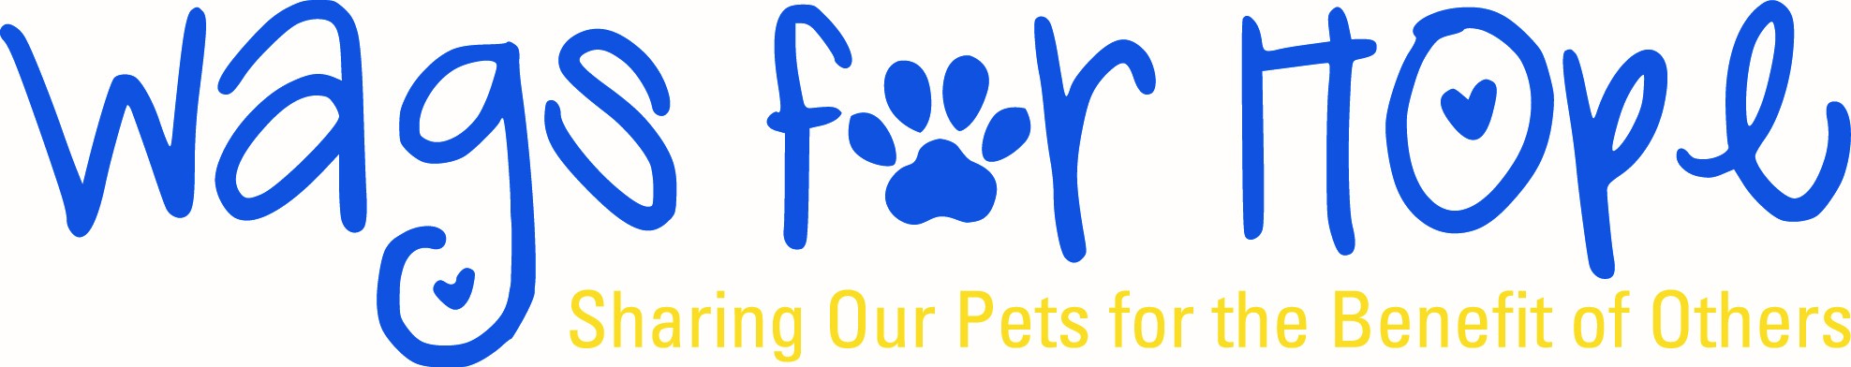
Volunteer Pet Team Agreement
I understand and agree to all requirements of the Wags for Hope Team Agreement and have been provided a copy of the agreement.

________________________________________________________________________________________
Volunteer’s Signature Date

Liability Waiver
I hereby release and forever discharge Charlie’s Dream, Inc. doing business as Wags For Hope, its staff and volunteers, members and Board of Directors from any and all liabilities relating to any damages and/or harm of person and/or property which I may incur or suffer as a result of my visitations. I assume all risks with the volunteer activities in which I participate.

_________________________________________________________________________________________
Volunteer’s Signature Date

_________________________________________________________________________________________
Please Print Name

